**Topic 1: Data Layer Mastery**

The **Data Layer** is a JavaScript object that stores information you want to pass to Google Tag Manager. It allows GTM to access dynamic data that’s not easily available in HTML, like user type, product or login status.

**Step 1: Modify HTML with a click script**

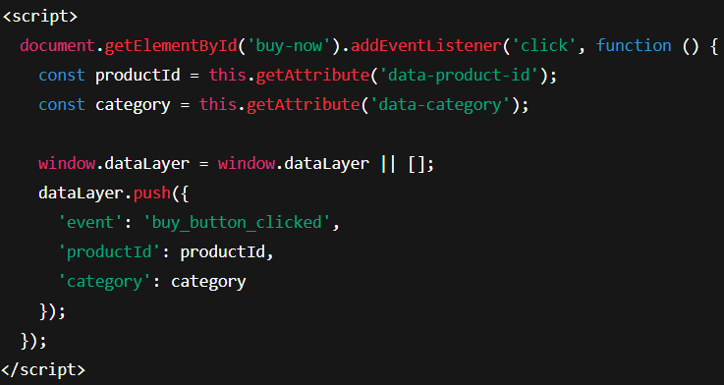

**Step 2: Set Up GTM to catch this Event**

* Go to GTM🡪 Triggers🡪 New
* Trigger Type: Custom Event
* Even Name: buy_button_clicked
* Trigger Name: Buy Button Click

**Step 3: Create Tag to send Event to GA4**

* Tags🡪 New
* Tag Type: GA4 Event
* Configuration Tag: Select your existing GA4 configuration
* Event Name: buy_button_clicked
* Event Parameters:
* productid🡪{{DL – productid}}
* Category🡪{{DL – Category}}

*(Create Data Layer Variables if they don’t exist)*

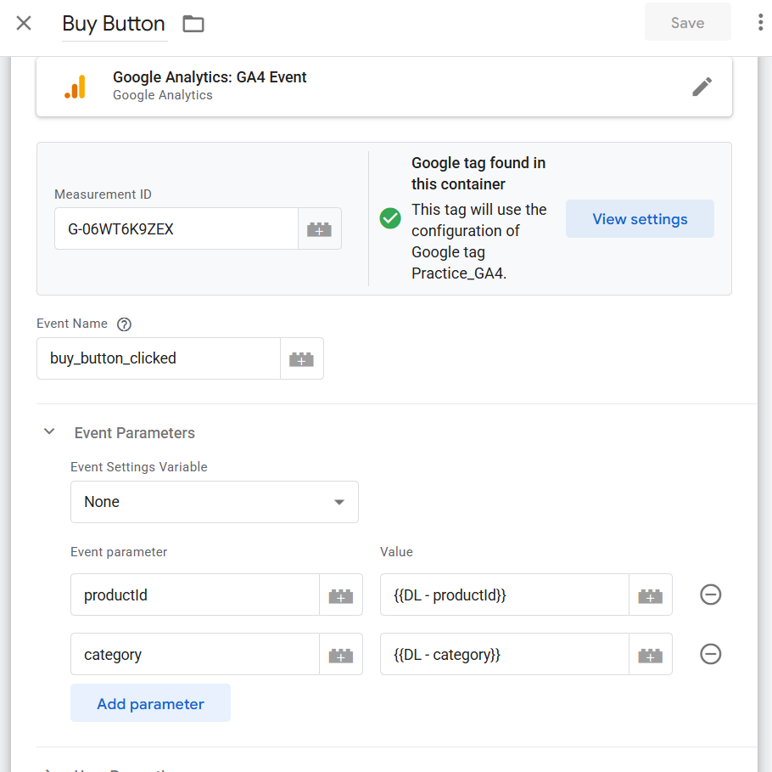

* Trigger: Choose Buy Button Click

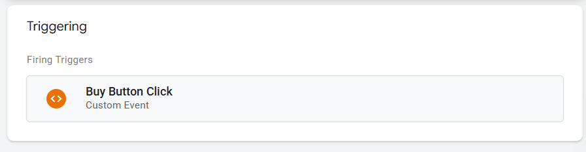

( **NOTE** : If your event parameter are not in the built-in variables then you need to add new variables in user-defined variables Inside the Variables tab)

**Topic 2: Custom Event Tracking**

Custom events let you track **user interactions** that don’t cause the page to reload ( like clicks, scrolls, form submissions, video views). These aren’t automatically tracked by GA4, so **GTM helps for them** to send the data.

**Step 1: Add HTML code for button. We are going to add example button “download-pdf”.**

**Step 2: Fire a custom event on click**

* Add a JavaScript inside the webpage code.

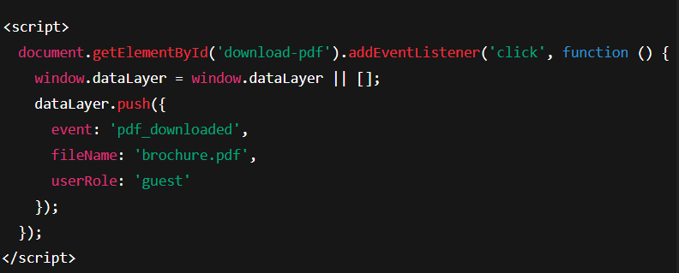

**Step 3: Set Up GTM Trigger**

* Go to GTM🡪 Triggers 🡪 New
* Trigger Type: Custom Event
* Event Name: pdf_download
* Name: PDF Download Trigger
* Click Save

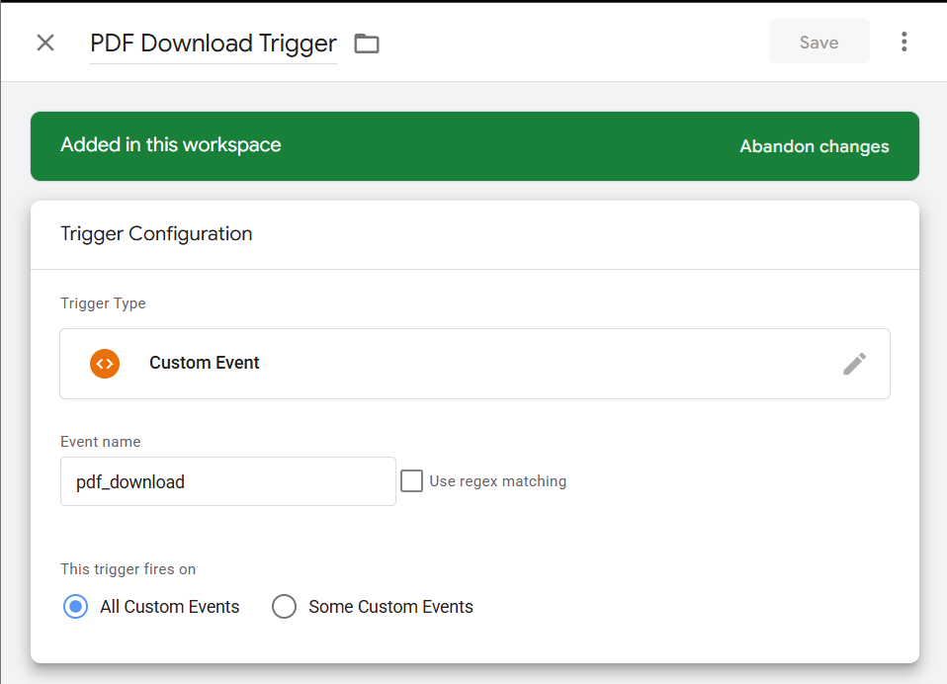

**Step 4: Create Data Layer Variables**

Go to GTM🡪 Variables🡪 New

1. DL – fileName

* Type: Data Layer Variable
* Name: fileName

1. DL – userRole

* Type: Data Layer Variable
* Name: userRole

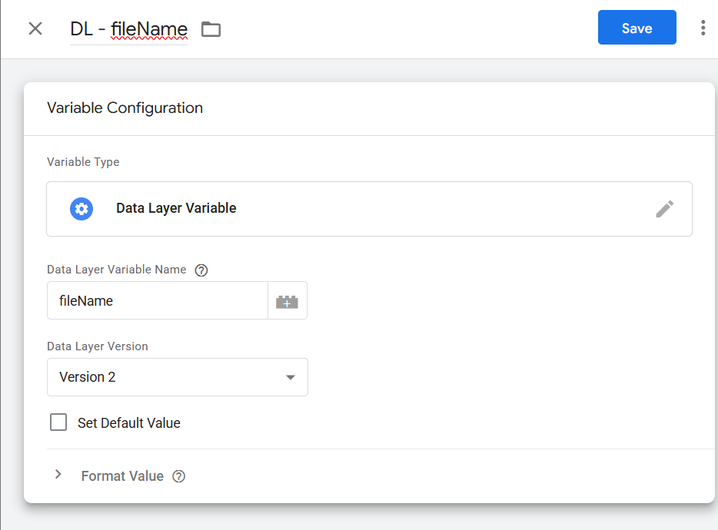

**Step 5: Create GA4 Tag**

* Go to GTM🡪 Tags🡪 New
* Tag Type: GA4 Event
* Configuration: Select your GA4 tag
* Event Name: pdf_download
* Event Parameters:
  + - file_name🡪{{DL – filename}}
    - user_role🡪{{DL – userRole}}
* Triger: Use PDF Download Trigger
* Click Save

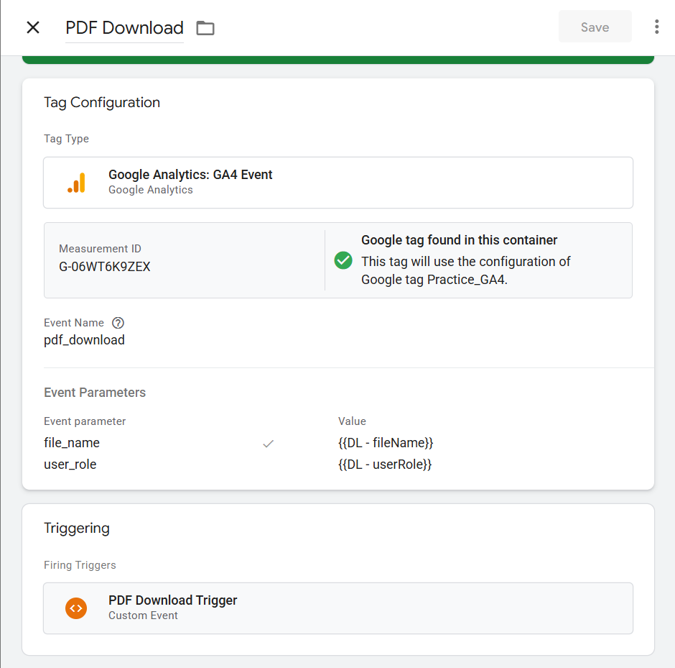

**Topic 3: Track how long user stays on the website.**

We will track how long a user stays on the page and send an event to GA4 when they have been there for a set time (e.g 10 seconds).

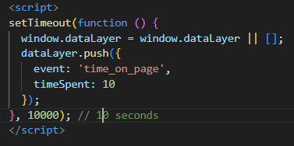**Step 1: Add timer event to your webpage (Using JavaSript)**

This pushes an event to the dataLayer after 10 seconds.

**Step 2: Set up the Trigger in GTM**

* Go to GTM🡪 Triggers🡪 New
* Name it: 10 Seconds on Page
* Trigger type: Custom Event
* Event Name: time_on_page
* Click Save

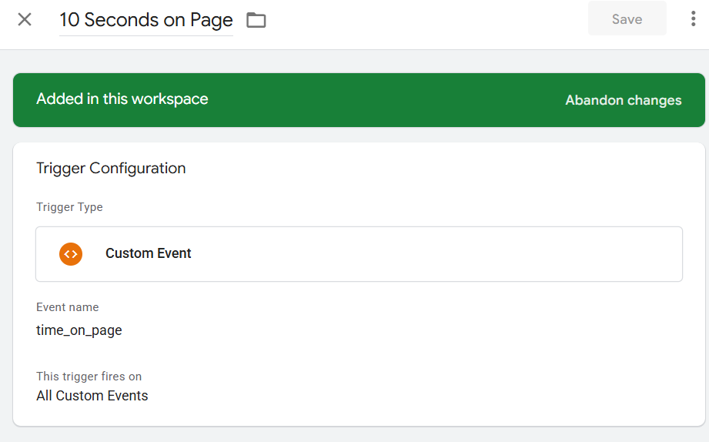

**Step 3: Create a Data Layer Variable ( for timeSpent)**

* Go to GTM🡪 Variables🡪 New
* Name: DL – timeSpent
* Variable type: Data Layer Variable
* Data Layer Variable Name: timeSpent
* Click Save

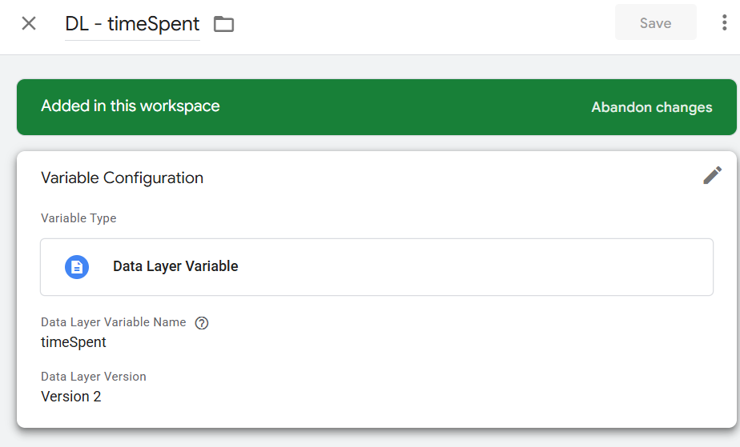

**Step 4: Create a GA4 Tag**

* Go to GTM🡪 Tags🡪 New
* Tag type: GA4 Event
* Configuration Tag: (your GA4 config tag)
* Event Name: time_on_page
* Event Parameters:
  + - time_spent:{{DL – timeSpent}}
* Trigger: 10 Seconds on Page
* Click Save

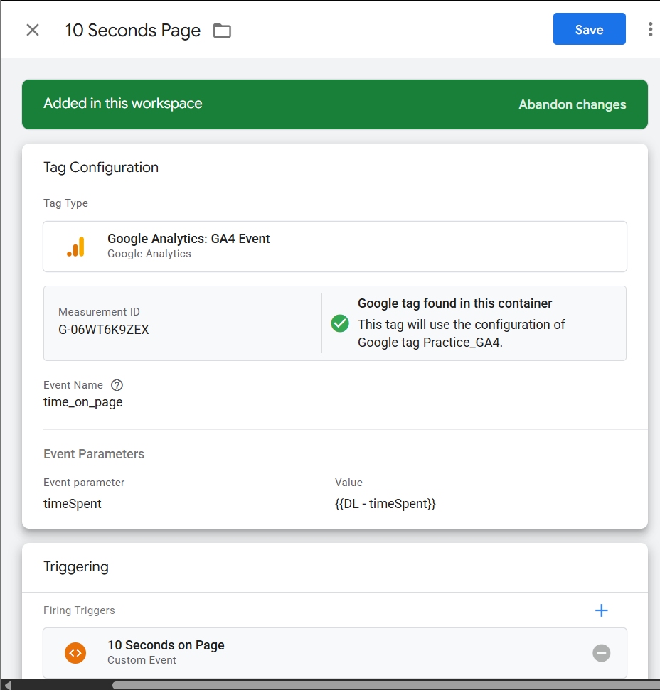

**Topic 4: Scroll Tracking**

Scroll Tracking is useful when we want to know how far user scroll on a page.

We’ll setup a GTM to fire an event to GA4 when a user scrolls 25%, 50%, 75%and 100% down the page.

**Step 1: Enable Built-in Scroll Variables**

* In GTM, go to Variables
* Click Configure
* Enable:
  + - Scroll Depth Threshold
    - Scroll Depth Units
    - 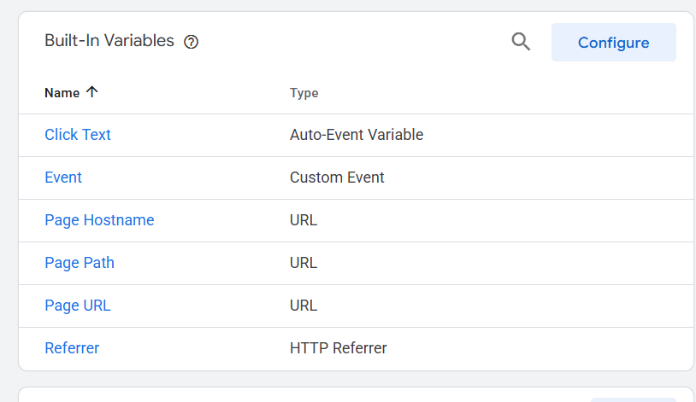Scroll Directions

**Step 2: Create a Scroll Trigger**

* 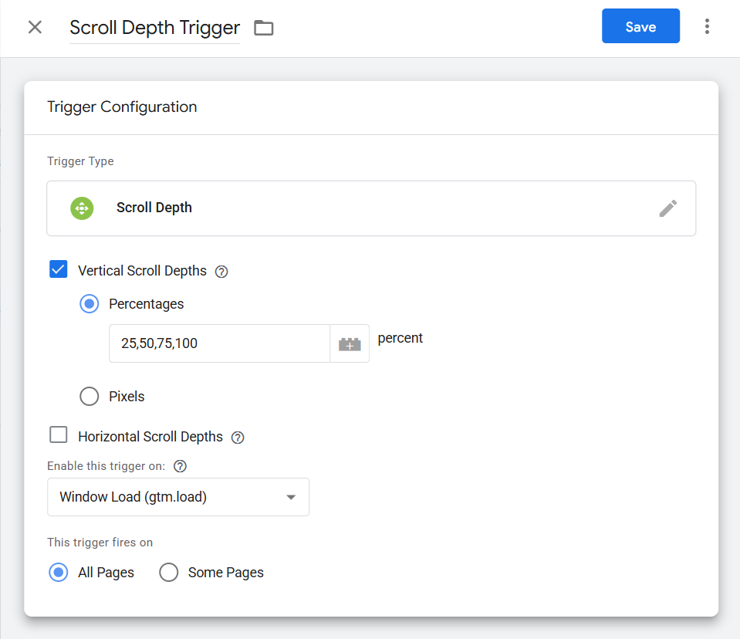Go to Triggers🡪 New
* Name : **Scroll Depth Triggers**
* Trigger Type: **Scroll Depth**
* Configure:
  + - * Vertical Scroll Depths **25, 50,75, 100**
      * Scroll Units: Percent
      * Trigger Fires on : All Pages
* Click Save

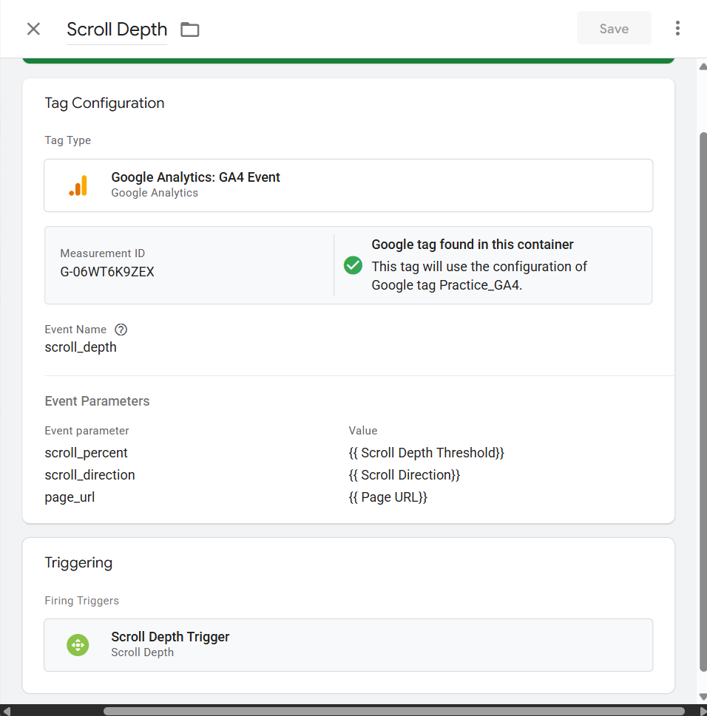**Step 3: Create a GA4 tag for Scroll Events**

* Go to Tags🡪 New
* Name: **GA – Scroll Depth**
* Tag Type: **GA4 Event**
* Event Name: scroll_depth
* Event Parameters:
  + - * + scroll_percent🡪{{ Scroll Depth Threshold}}
        + scroll_direction🡪{{Scroll Direction}}
        + page_url:{{Page URL}}
* Choose Trigger: Scroll Depth Trigger
* Click Save

**Topic 5: Cookie Consent Integration**

This determines if the user doesn’t accept cookies, your analytics tags should not fire. This integration lets you accept privacy while still tracking legally and properly.

**Step 1: Understand consent mode in GTM**

* + GTM has built-in consent settings for each tag

**Step 2: Add CookieScript Consent Control to site**



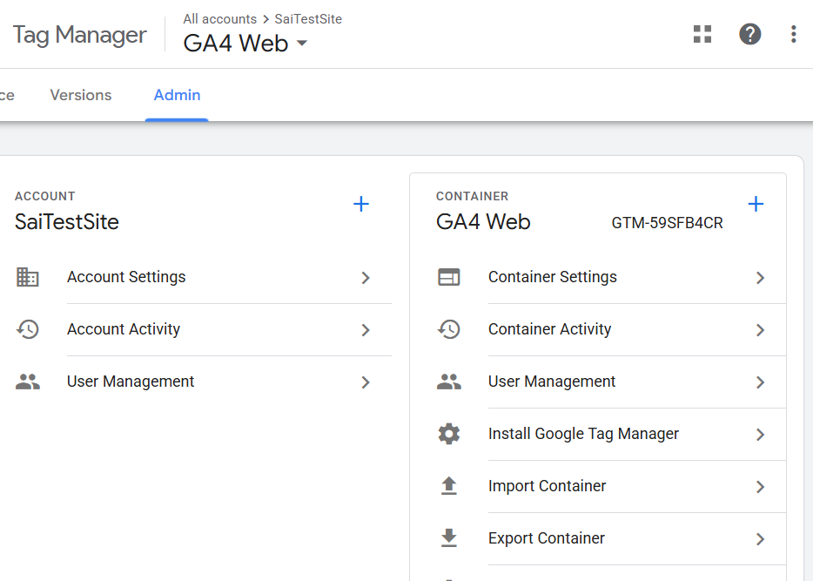

**Step 3: Enable Consent Mode in GTM**

* + - Go to Admin🡪 Container Settings
    - Enable “**Built-in consent Checks**”
    - Save

**Step 4: Set Consent in Tags**

* 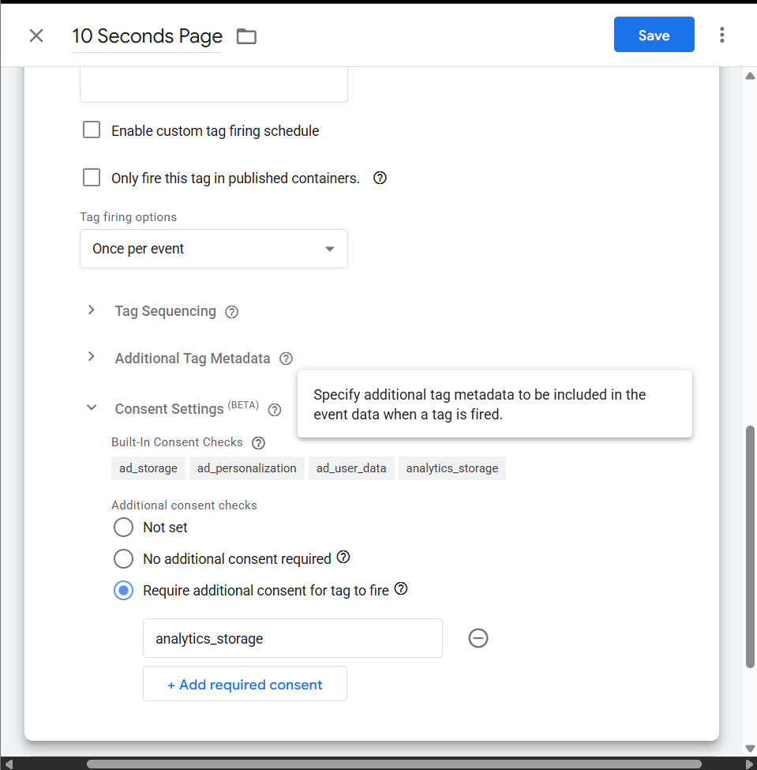Go to each **tag**
* Edit the tag
* Expand the “**Consent Settings**” section
* Enable “**Require additional consent**”
* Add:
  + - analytics_storage

Now the tag **will only fire** if the consent is granted

**Step 5: Fire Tags After Consent**

* Go to Triggers🡪 New
* Trigger Type: Consent Initialization
* 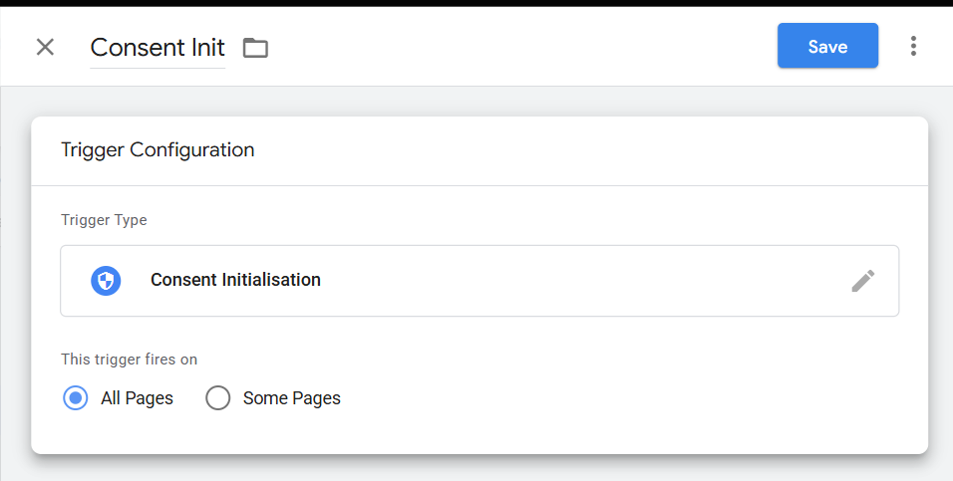Name: Consent Init

This triggers fire before other tags and is used to configure consent properly.